Analyzing the Relationship between Daily Lifestyle Factors and Sleep Quality Using Personal Data

1. Motivation
Quality of sleep has crucial consequences on daily life, overall health and productivity. Since I am someone who actively tries to become my healthiest version, I was already monitoring my personal sleep patterns, daily nutrition and activity levels. There are various conflicting opinions on lifestyle online on nutrition, exercise, optimal sleep habits etc., so I wanted to see for myself how much each factor affects my sleep. Weather and physical activity are also among the external factors that affect energy levels. This project aims to use data science methods to analyze these factors and provide evidence-based results that may help guide individuals who are interested in improving their sleep quality through different lifestyle decisions.

2. Data Source and Data Collection
The dataset consists of 20 consecutive days of personal lifestyle and sleep data collected in CSV format.

2.1 Personal Data
The following variables were recorded daily:
- Date
- Last meal time
- Daily carbohydrate intake (g)
- Daily protein intake (g)
- Daily fat intake (g)
- Daily water intake (liters)
- Physical activity (yes/no)
- Daily sleep duration (hours)
- Daily sleep quality (self-reported on a scale of 1–10)
Macronutrient intake and water consumption were tracked using mobile nutrition and hydration tracking applications. Sleep duration was tracked by an Apple Watch sleep tracking feature while sleep quality was manually recorded based on subjective perception.

2.2 External Data
Daily weather information was collected manually from AccuWeather. Minimum and maximum daily temperatures were recorded and averaged to compute a representative daily temperature value.

3. Preparing Data for Analysis
Before the actual analysis, the following steps were taken to purify the data:
- Transforming data to fit to data science tools:
  - Last meal time was converted into a numerical hour-based value.
  - Physical activity was turned into a binary variable (1 = activity performed, 0 = no activity).
- Scaling: Numerical features were standardized where needed.
- Derived features: A binary late meal indicator was created to pinpoint late evening eating behavior.

4. Exploratory Data Analysis (EDA)

4.1 Statistics
Across the 20-day period, average sleep duration was approximately 7.19 hours while mean sleep quality score was 7.45/10. Macronutrient intake showed moderate variability with carbohydrate intake ranging from 28 g to 143 g and protein intake from 50 g to 122 g.

4.2 Distribution Analysis
Histograms revealed the following:
- Macronutrient distributions were moderately skewed, particularly carbohydrates and fat.
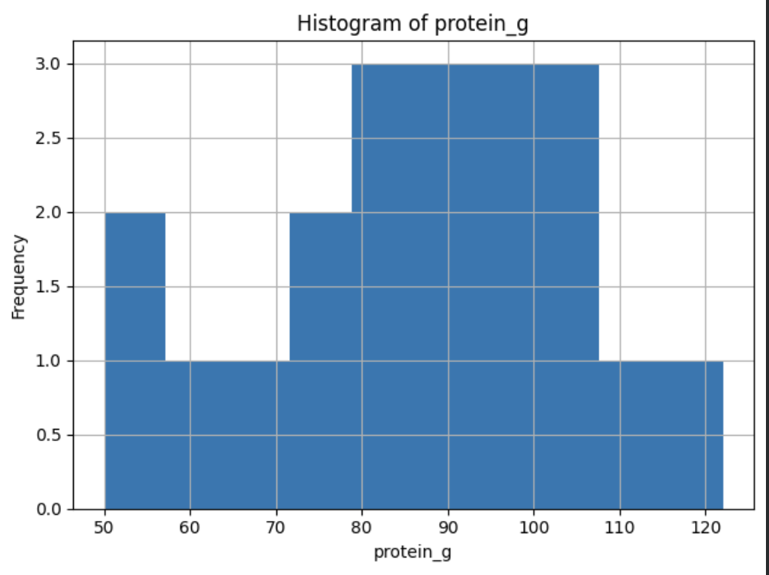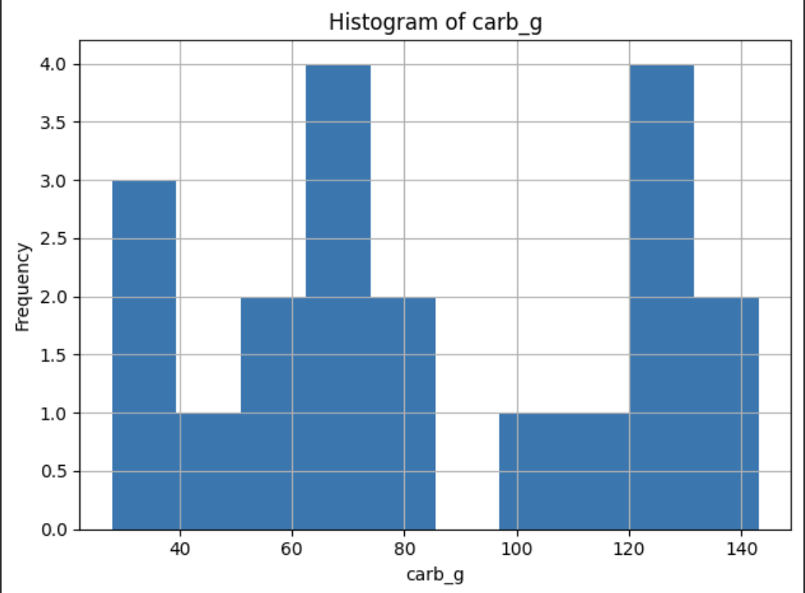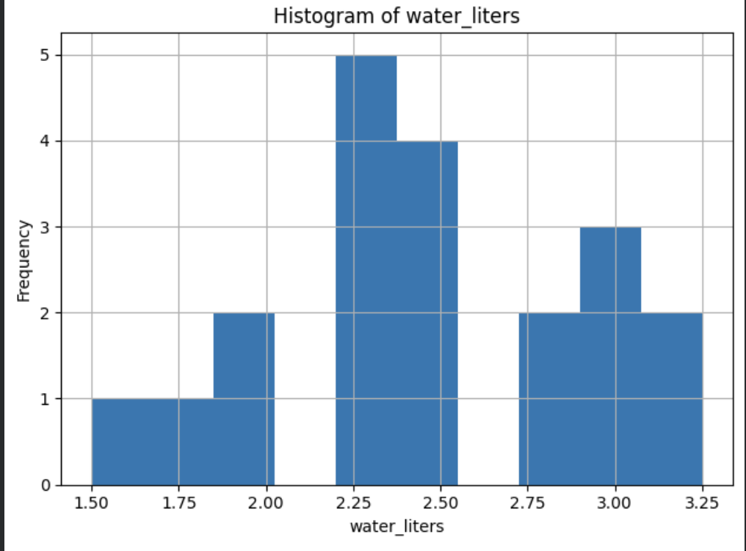
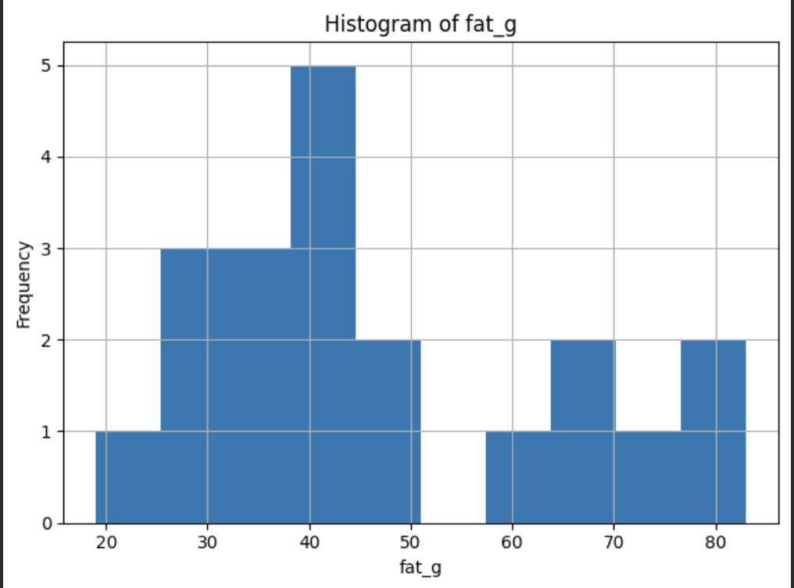
- Sleep duration clustered around 6–8 hours with a few longer and few shorter sleep times.
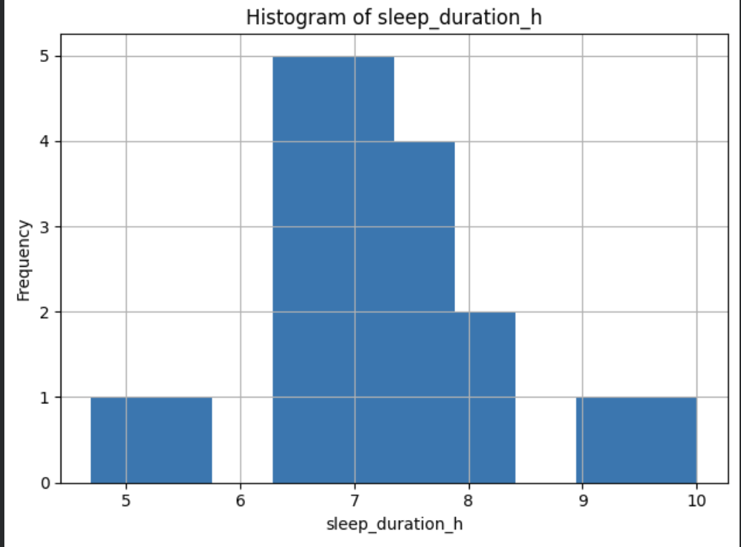
- Sleep quality scores ranged from 4 to 10 with most values between 6 and 9.
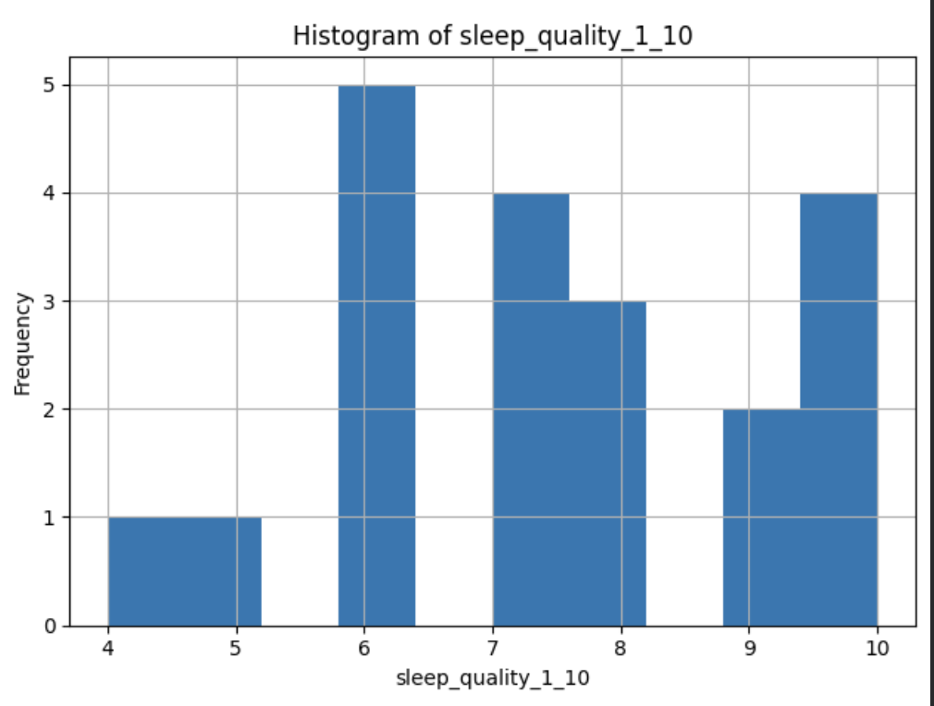

4.3 Pairwise Relationships and Correlation Analysis

Pearson correlation coefficients were computed for all variables: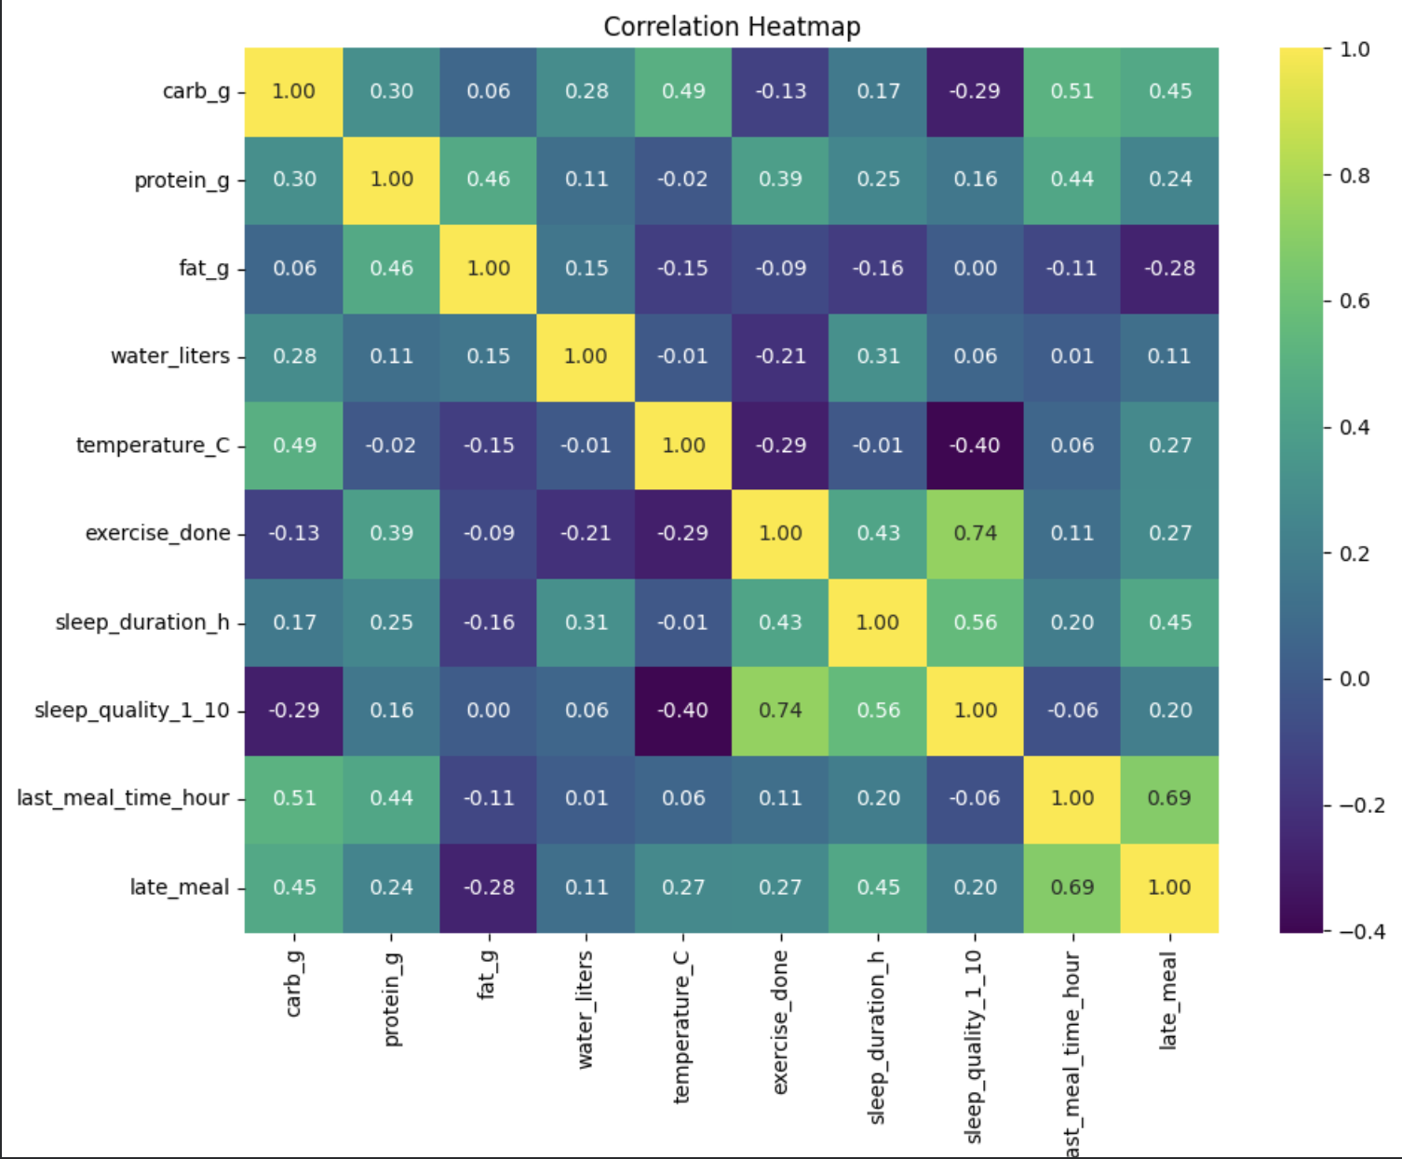
- Sleep quality vs. physical activity: Strong positive correlation (r = 0.74), indicating higher sleep quality on days with physical activity.
- Sleep quality vs. sleep duration: Moderate positive correlation (r = 0.56), suggesting longer sleep duration is associated with better sleep quality.
- Sleep quality vs. carbohydrate intake: Moderate negative correlation (r = −0.29).
- Sleep quality vs. temperature: Moderate negative correlation (r = −0.40), indicating higher temperatures may negatively affect sleep quality.
- Sleep quality vs. water intake: Very weak positive correlation (r ≈ 0.06).
- Sleep quality vs. last meal time: Weak negative correlation (r ≈ −0.06).
These relationships were visualized using scatter plots and a correlation heatmap.
5. Hypothesis Testing
Several hypothesis tests were conducted to assess specific relationships.

H2: Eating Later in the Evening Reduces Sleep Duration
- Mean sleep duration (late meal = 1): 8.71 hours
Mean sleep duration (late meal = 0): 7.02 hours
- Two-sample t-test: p = 0.4102
- Mann–Whitney U test: p = 0.1684
Conclusion: No statistically significant difference was found.

H3: Higher Carbohydrate Intake Is Associated with Lower Sleep Quality
- Pearson correlation: r = −0.293, p = 0.2104
Spearman correlation: ρ = −0.272, p = 0.2466
Conclusion: A negative trend exists, but the relationship is not statistically significant.

H4: Sleep Quality Is Higher on Days with Physical Activity
- Mean sleep quality (exercise = 1): 8.50
- Mean sleep quality (exercise = 0): 5.88
- Two-sample t-test: p = 0.0001
- Mann–Whitney U test: p = 0.0011
Conclusion: The hypothesis is strongly supported; physical activity is associated with significantly higher sleep quality.

6. Machine Learning Methods

6.1 Problem Definition
The task was defined as a regression problem with daily sleep quality (1–10) as the target variable.

6.2 Models
The following models were applied:
- Baseline Mean Predictor
- Ridge Regression
- Random Forest Regression

6.3 Evaluation Strategy
Due to the small dataset size, a time-aware holdout strategy was used, reserving the last three days as the test set.

6.4 Results
Random Forest achieved the best performance, indicating that non-linear relationships among features contribute to sleep quality prediction.

7. Findings and Discussion
The analysis found that physical activity and sleep duration were the most crucial factors for sleep quality. Nutritional factors such as carbohydrate intake show weaker and non-significant relationships, while environmental factors like temperature demonstrate moderate negative associations.
8. Limitations and Future Work
The most challenging limitation of this study is the small sample size (20 days) which limits the reliability of the data. Sleep quality is also self-reported which indicates subjectivity. Future work may include longer data collection periods and the usage of objective metrics to gather healthier data.

10. Conclusion
This project demonstrates how personal lifestyle data can be analyzed using data science techniques to find meaningful patterns related to sleep quality. Despite dataset limitations, the findings suggest that physical activity and sufficient sleep duration play a critical role in improving sleep quality while other factors such as nutrition and temperature may have secondary effects.

